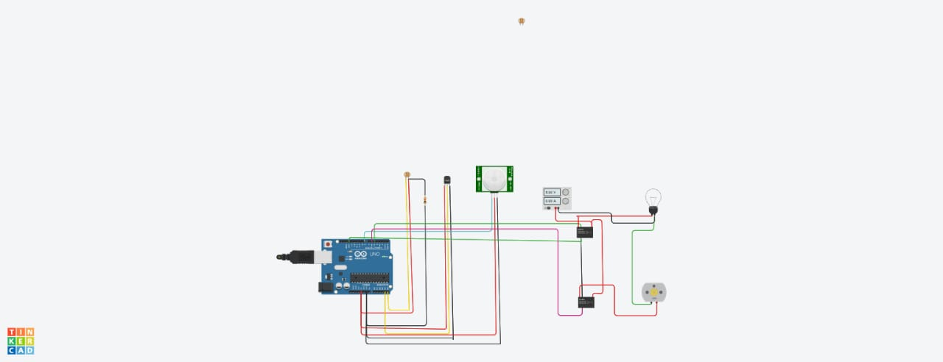

**CODE:**

**int const PINO_SGAS = A1;**

**int LED_VERDE = 7;**

**int LED_AMARELO = 6;**

**int LED_VERMELHO1 = 5;**

**int LED_VERMELHO2 = 4;**

**void setup(){**

**pinMode(LED_VERDE, OUTPUT);**

**pinMode(LED_AMARELO, OUTPUT);**

**pinMode(LED_VERMELHO1, OUTPUT);**

**pinMode(LED_VERMELHO2, OUTPUT);**

**Serial.begin(9600);**

**}**

**void loop(){**

**int valor = analogRead(PINO_SGAS);**

**valor = map(valor, 300, 750, 0, 100);**

**digitalWrite(LED_VERDE, HIGH);**

**digitalWrite(LED_AMARELO, valor >= 30 ? HIGH : LOW);**

**digitalWrite(LED_VERMELHO1, valor >= 50 ? HIGH : LOW);**

**digitalWrite(LED_VERMELHO2, valor >= 80 ? HIGH : LOW);**

**delay(250);**

**}**